GUIDELINES

FOR THE PREPARATION OF B.E.PRACTICE SCHOOL.REPORT

DEPARTMENT OF
COMPUTER SCIENCE AND
ENGINEERING

 | MANIPAL INSTITUTE OF TECHNOLOGY,  (A Constituent Institute of MANIPAL UNIVERSITY)  MANIPAL - 576 104, Karnataka, India. | 

The arrangement in parts of B.E. Practice school report is as follows:

- COVER PAGE
- INSIDE COVER PAGE
- QUOTATIONS (if any)
- DEDICATION PAGE (if any)
- CERTIFICATES
- Certificate from college (Scroll down for the format)
ii) Certificate from company(Xerox copy)
- ACKNOWLEDGEMENTS
- ABSTRACT
- TABLE OF CONTENTS
- LIST OF TABLES
- LIST OF FIGURES
- ABBREVIATIONS (if any)
- NOTATIONS (if any)
- CHAPTERS
- REFERENCES

The formats for various headings are given below.

1. | THE COVER PAGE | The fonts and locations of various items on this page should be exactly as shown in Annexure-1A (for BE) and Annexure-1B (for M.Tech).
2. | INSIDE COVER PAGE | Same as the cover page
3. | QUOTATIONS: | This should not exceed one page
4. | DEDICATION PAGE | This should not exceed one page.
5. | CERTIFICATE(S) | The fonts and locations of the various items on the certificate should be exactly as shown in Annexure-2 The students must also submit a certificate from the concerned authority of industry in which they have carried out the practice school work..
6. | ACKNOWLEDGEMENTS | This should not exceed two pages.
7. | ABSTRACT | This should not exceed two pages (about 600 words) and should contain not more than 6 key words. See Annexure-3.
8. | TABLE OF CONTENTS | See Annexure-4.
9. | LIST OF TABLES | See Annexure-5.
10. | LIST OF FIGURES | Same format as in list of Tables.
11. | ABBREVIATIONS | See Annexure-6.
12. | NOTATION | See Annexure-7.
13. | CHAPTERS | See Annexure-8
14. | REFERENCES | References should be complete in all respects. Indicative examples are provided in Annexure-9

STYLE NOTES FOR PRACTICE SCHOOL REPORT PRODUCTION

1. PAPER
- Use A4 (210 mm X 297 mm) bond un-ruled paper (80 gsm) for all copies submitted. Use one side of the page only for all printed / typed matter.

2. NUMBERING
- Pages
- Every page in the Project Report except the Title page must be accounted for.
- The page numbering, starting from acknowledgements and till the beginning of the introductory Chapter should be printed in small Roman numbers, i.e. i. ii. iii. iv ……..
- All printed page numbers should be located at the bottom center of the page, 17 mm (2/3”) from the bottom edge, using normal print.
- Chapters
  - Use only Arabic numerals. Chapter numbering should be centered on the top of the page using large bold print.

Example: CHAPTER 1
- Sections
  - Use only Arabic numerals with decimals. Section numbering should be left justified using bold print.
  - Example: 1.1, 1.2, 1.3, etc.
- Subsections
  - Use only Arabic numerals with two decimals. Subsection numbering should be left justified using bold print.
  - Example: 1.1.1, 1.1.2, 1.1.3, etc.
  - NOTE: Sub- section levels beyond the third level (e.g. 1.2.1.1, 3.2.1.3, etc.) are not recommended.

e) Equation(s) / Formula (e)
  - Use only Arabic numerals with single decimal. Equation numbers should be right justified using normal print. Mathematical symbols should be printed in italics.
  - Format: (<Chapter number> . <Equation serial number>)
  - Examples: (Please note that the equation numbers are flush right in normal print).
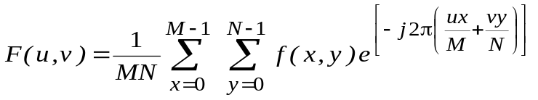 (5.1)
for, u = 0, 1, 2 . . . . . M – 1 and v = 0, 1, 2 . . . . . N – 1.
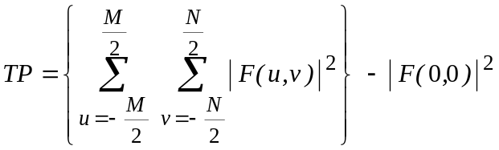. (5.2)
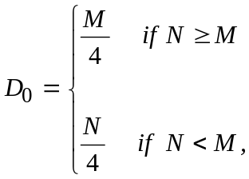 (5.3)
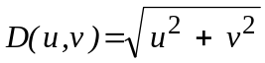. (5.4)
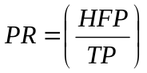 x 100 (5.5)
References
  - Use only Arabic numerals. Serial numbering. Alphabetical order of surname or last name of first author.
  - Two or more references by same author(s) in the same year should be indicated by small – case alphabets in italics.

3. TEXT
- Colour: Black print
- Font:
Regular text | Times Roman 12 pts. and normal print
CHAPTER HEADINGS | Times Roman 15 pts. and bold print and all capitals.
SECTION HEADINGS | Times Roman 12 pts. and bold print and capitals.
Subsection Headings | Times Roman 12 pts., bold print and leading capitals, i.e. only first letter in each word to be in capital.
Special Text | Italics / Superscript / Subscript / Special symbols etc., as per necessity. Special text may include footnotes, endnotes, physical or chemical symbols, mathematical notations, etc.
References | Same font as regular text. Serial number and all authors’ names to be in bold print. Journal names and book titles in italics. For format see Annexure 10

- Spacing:
  - Use double spacing between the lines.
  - Use triple spacing between paragraphs.
  - All paragraphs in the project report should be left justified completely, from the first line to the last line.
  - Use double spacing between the regular text and quotations.
  - Provide three spaces between:
    - Chapter title and first sentence of a Chapter.
    - Last line of a section / sub-section and the title of the next section / sub-section.
    - Paragraphs.
- Use single spacing between:
  - In footnotes and endnotes for text.
  - In explanatory notes for tables and figures.
  - In text corresponding to bullets, listings, and quotations in the main body of the project report.
- Use single space in references and double space between references.
- Justification
- The text should be fully justified.
- Hyphenation should be avoided as far as possible.
- Text corresponding to bullets and listings should be intended.
- Quotations from other research work must be indented on the left and the right, if they are longer than two lines. Shorter quotations can be included as part of the regular text.

- Widows and Orphans

- At the bottom of a page, a paragraph should have at least two lines. Similarly at the top of a page, a paragraph should end with at least two lines
4. MARGINS
- The margin for the regular text are as follows:
LEFT | 31.7 mm (1.25”)
RIGHT | 31.7 mm (1.25”)
TOP | 25.4 mm (1.00”)
BOTTOM | 17.0 mm (0.67”)
- Please note that the bottom of the page numbers should be 17.0 mm above the bottom edge of the numbered pages.
5. TABLES
- A sample of Table is provided in Annexure-9.
- All Tables should have sharp lines, drawn in black ink, to separate rows/columns as and when necessary.
- Tables should follow immediately after they are referred to for the first time in the text. Splitting of paragraphs, including Tables on a page, should be avoided. Provide three spaces on the top and the bottom of all Tables to separate them from the regular text, whenever applicable.
- The last line of the title of any Table should be 10 mm to 15 mm above the top-most horizontal line of the Table, and the title should be centered with respect to the Table. The titles must be in the same font as the regular text and should be single- spaced. The title format is given below:
- Whenever a Table exceeds one page, present the full title of the Table on the first page and in the following pages provide the Table number and state “(contd.)” after it. Example: Table 5.7 (contd.)
- Whenever explanatory notes are used for clarifying any information presented inside the Tables, print them after leaving a single space immediately below the Tables.
- All Tables in landscape format must be placed such that their top portions are near the binding of the project report and their bottom portions near the outer edge.
- Table<blank><chapter number>.<serial number><left indent><table title>

6. FIGURES
- Sample of a Figure is provided in Annexure-9.
- All Figures, drawings, and graphs should be drawn in black ink with sharp lines and adequate contrast between different plots if more than one plot is present in the same graph.
- Figures should follow immediately after they are referred to for the first time in the text. Splitting of paragraphs, for including Figures on a page, should be avoided. Provide three spaces on the top and bottom of all figures to separate them from the regular text, wherever applicable.
- The first line of the title for Figures, drawings, graphs and photos should be between 10 mm and 15 mm below the bottom and they should be centered with respect to the Figure. The titles must be in the same font as the regular text and should be Single spaced. The title format is given below:
- Fig.<blank><Chapter number>.<serial number><left indent><Figure title>
- Example: Fig. 4.23
- Whenever a Figure exceeds one page (as in the case of large flow charts for computer programs) present the full title of the figure on the first page and in the following pages provide the figure number and state “(contd.) after it.
- Example: Fig. 4.23 (contd.)
- When there are many plots in a single graph or Figure, the lettering, labeling or numbering of each plot for its identification should be of a size such that even after size reduction in the project report, the identification should be clearly legible.
- All Figures in landscape format must be placed such that their top portions are near the binding of the project report and their bottom portions near the outer edge.
7. PHOTOS

- Use colour photos only if they are necessary. Remember that the project report may have to be photocopied. In case colour photos are used, all copies of the project report must contain only colour photos.
- Each photo should be numbered and referred to as a Figure. Photo titles should be similar to those provided for Figures.

(Note: This is the format of cover page and inside cover page)
CLASSIFICATION OF ……..USING NEURAL NETWORKS AND FUZZY LOGIC
Annexure – 1

A practice school report submitted

to

MANIPAL UINIVRESITY

For Partial Fulfillment of the Requirement for the
Award of the Degree

of

BACHELOR OF ENGINEERING
in

COMPUTER SCIENCE AND ENGINEERING

by

MANJUNATH
RITHESH KINI

Under the Guidance of

Mr. SURESH JAIN
Reader, Department of Computer Science and Engineering
and
Mr. ABHISHEK KUMAR
Designation, Address of the company
DEPARTMENT OF COMPUTER SCIENCE AND ENGINEERING
MANIPAL INSTITUTE OF TECHNOLOGY
(A constituent Institute of MANIPAL UNIVERSITY)
MANIPAL - 576 104, KARNATAKA, INDIA

2011
(Note: This is the format of college certificate)
MANIPAL INSTITUTE OF TECHNOLOGY
Annexure – 2
(A constituent Institute of MANIPAL UNIVERSITY )
MANIPAL – 576 104 .
DEPARTMENT OF COMPUTER SCIENCE AND ENGINEERING
CERTIFICATE
This is to certify that the practice school titled “DIGITAL STEGANOGRAPHY FOR MEDICAL INFORMATION EXCHANGE” is a bonafied work of
LLOYD LOBO  MOHANDASA NAYAK | 4MI98BM013  4MI98BM031
carried out in partial fulfillment of the requirements for awarding the degree of Bachelor of Engineering in Biomedical discipline in Manipal Institute of Technology under MANIPAL University, Manipal during the academic year 2006-2007.

Name of the external gude,
Designation
Name of the organisation

Mr. Jathan Kumar  Designation  Project Guide | Dr. Prema K. V.  Professor & Head  Dept. of Computer Science and Engineering

ABSTRACT
Annexure - 3
KEYWORDS: Diabetic neuropathy; optical pedobarograph; foot pressures; power ratio; early plantar ulcer detection; ANN foot model.
In diabetic patients, neuropathy (loss of sensation) is the primary etiologic factor. Due to the sensory neuropathy, patients are unable to sense pressure, pain or micro trauma on the foot. An injury or infection in the neuropathic foot results in a serious medical condition often leading to amputation. Therefore foot problems in patients with diabetes mellitus are a major public health concern these days. The present study is aimed at using new diagnostic pressure parameters and correlating them to quantified plantar sensation to understand pressure distribution patterns under the soles of diabetic feet in different levels of sensation loss, possibly responsible for ulcer formation. Sensations of plantar surface of the diabetic foot (in ten standard foot sole areas) are quantified using Semmes–Weinstein monofilaments and classified into four different categories. Standing and walking foot pressure measurements are carried out using optical pedobarograph.
In the space domain analysis of walking foot pressures, studies are performed on 20 normal and 40 diabetic feet in different levels of sensation loss, using new diagnostic parameters, normalised peak pressure (NPP), pressure contact ratio (PCR) and their gradients (relative difference). It is found that the values of these foot pressure parameters of diabetic patients are much higher than those of normal subjects in general and these values increase with degree of neuropathy, in all the areas of the foot. But these pressure parameters in the space domain analysis could not distinguish clearly the diabetic feet in different levels of loss of sensation.
A detailed analysis is performed first on standing foot pressure images in frequency domain. A new parameter, power ratio (PR, ratio of power in higher spatial frequency components to the total power in an image) is used to distinguish between the foot pressure image patterns of diabetic neuropathy subjects (in different levels of sensation loss) and those of normal foot. The results could help to detect the early stages of neuropathy responsible for plantar ulcers only in the heel of diabetic feet.
The study is carried out further to analyse walking foot pressure images of diabetic subjects in different levels of neuropathy and use the same parameter power ratio, PR (defined earlier) to distinguish normal from the diabetic feet. The parameter is able to distinguish clearly the normal from the diabetic feet and also make clear distinctions without overlap between diabetic feet in different levels of loss of sensation. The result could help to detect the early stages of neuropathy responsible for plantar ulcers in both the heel and fore-foot areas of diabetic feet.
Two comprehensive foot models are developed using artificial neural networks with pressure parameters, namely, NPP, PCR and PR are used as input variables and sensation levels as output variable. The nonlinear model helps in classifying the foot in the category of normal and diabetic in different levels of sensation loss. The neural network model can be trained with sufficient number of data sets of foot pressure parameters corresponding to the ulcer at early stage neuropathy. This model then could help in detecting the plantar surface of foot likely to have ulcer and the information can be utilised by orthopaedic surgeons to devise early corrective methods to prevent the foot-sole ulcers and enhance the quality of life by avoiding the lower limb complications of diabetes.

TABLE OF CONTENTS
Annexure - 4
 |  |  | Page
ACKNOWLEDGEMENTS |  |  | i
ABSTRACT |  |  | iii
LIST OF TABLES |  |  | ix
LIST OF FIGURES |  |  | xi
ABBREVIATIONS |  |  | xv
NOTATION |  |  | xvii
CHAPTER 1 |  | INTRODUCTION
1.1 | General |  | 1
1.2 | Diabetes |  | 1
1.2.1 | Foot Problems in Diabetes |  | 3
1.2.2 | Ulcer Formation |  | 3
1.2.3 | Sites of Neuropathic Ulcers |  | 5
1.2.4 | Anaesthesia and Sensory Paralysis due to Diabetes |  | 6
1.2.5 | Causes of Ulceration |  | 8
1.2.6 | Foot Bone Damage |  | 9
1.3 | Anatomy of the Foot |  | 10
1.3.1 | Foot Skeleton |  | 10
1.3.2 | Arches of the Foot |  | 12
1.3.3 | Muscles of the Foot |  | 13
1.4 | Organisation of the Thesis |  | 17
CHAPTER 2 |  | OVERVIEW OF THE LITERATURE
2.1 | Introduction |  | 19
2.2 | Significant Findings about Foot Pressures |  | 20
2.3 | Findings Regarding Diabetic Foot Pressures |  | 21

LIST OF TABLES
Annexure - 5
Table | Title | Page
3.1 | Details of Semmes–Weinstein nylon monofilaments used for classification of diabetic neuropathy | 39
4.1 | Comparison of mean of maximum NPP values [kPaN⁻¹(ms⁻¹)⁻¹] in the different foot areas for normal and diabetic subjects | 45
4.2 | Coefficients of correlation (r) between NPP values and levels of sensation (S) and the corresponding regression equations in different areas of the foot in diabetic subjects | 47
4.3 | Comparison of mean of maximum NPP gradient values [kPaN⁻¹(ms⁻¹)⁻¹/ pixel ] in the different foot areas for normal and diabetic subjects | 49
4.4 | Coefficients of correlation (r) between NPP gradient values and levels of sensation (S) and the corresponding regression equations in different areas of the foot in diabetic subjects | 51
4.5 | Comparison of mean of maximum PCR values [kPaN⁻¹(ms⁻¹)⁻¹] in the different foot areas for normal and diabetic subjects | 54
4.6 | Coefficients of correlation (r) between PCR values and levels of sensation (S) and the corresponding regression equations in different areas of the foot in diabetic subjects | 56
4.7 | Comparison of mean of maximum PCR gradient values [kPaN⁻¹(ms⁻¹)⁻¹ / pixel ] in the different foot areas for normal and diabetic subjects | 58
4.8 | Coefficients of correlation (r) between PCR gradient values and levels of sensation (S) and the corresponding regression equations in different areas of the foot in diabetic subjects | 60
5.1 | Comparison of mean values of PR (of left and right foot) in the different foot areas for normal subjects with different age from standing foot pressure image analysis | 74

ABBREVIATIONS
Annexure - 6

AH | Adductor Hallucis
ANN | Artificial Neural Network
BMP | Bit map
CCD | Charge Coupled Device
EDL | Extensor Digitorum Longus
EHL | Extensor Hallucis Longus
FDL | Flexor Digitorum Longus
FFT | Fast Fourier Transform
FHL | Flexor Hallucis Longus
HFP | High Frequency Power
IER | Inferior Extensor Retinaculum
LFP | Low Frequency Power
LOPS | Loss of Protective Sensation
MB | Mega Byte
MOS | Metal Oxide Semiconductor
MOSFET | Metal Oxide Semiconductor Field Effect Transistor
MTH | Metatarsal Head
NPP | Normalised Peak Power
NPP Grad. | Normalised Peak Power Gradient

NOTATIONS
Annexure - 7
a_{i} | Input variables for an artificial neural network
b_{k} | Output variables of an artificial neural network
M,N | The size of foot area image (in pixels)
n | The number of samples in a foot category
P | Peak pressure in the specified areas of the foot
p | Probability value of Student’s t – test
r | Correlation coefficient
S | Foot-sole sensation level
s_{i} | The output of input-layer of artificial neural network
s_{j} ^{h} | The output of hidden-layer of an artificial neural network
t | Time during which a pressure of 50% or higher of peak pressure acts on the specified foot area
T | Total contact time of the foot
u, v | Spatial frequency (in cycles per pixel) variables of a foot area image
V | Walking velocity
W | Weight of the subject
w_{ji}^{h} | Weights of the links between input and hidden layers of an artificial neural network
w_{kj}º | Weights of the links between hidden and output layers of an artificial neural network
x, y | Space variables (in pixels) of foot area image
θ_{j}^{h} | Bias term of hidden layer of artificial neural network
θ_{k}º | Bias term of output layer of artificial neural network
CHAPTER 1
Annexure - 8
INTRODUCTION
  - GENERAL
Diabetes continues to be one of the most common underlying factors associated with lower–extremity amputation in post–industrialised and developing countries (Armstrong et al., 1998a). Amputations are perhaps the most feared and well–recognised complication of diabetes by the general public. Ulceration is the most common single precursor to amputation and has been identified as a component in 85% of lower-extremity amputations (Pecoraro et al., 1990). Many studies have focused on neuropathy, in conjunction with elevated ground reaction forces, as the principal cause of these ulcerations. It is also hypothesised that at the cellular level, increased rate of tissue deformation may result in elevated intracellular calcium concentration, which may lead to cellular death subsequently causing ulcerations (Landsman et al., 1995). The present study is an effort to understand the pressure distribution patterns under the foot-soles of diabetic subjects at different levels of neuropathy (characterised by different grades of sensation loss) with new foot pressure parameters, possibly indicating the different stages in the progress of neuropathy and hence help to detect the early stages of neuropathy responsible for plantar ulcers.
  - DIABETES
Diabetes is a disorder caused by decreased production of insulin, or by decreased ability to use insulin. Insulin is a hormone produced by the pancreas that is necessary for the cells to be able to use blood sugar.
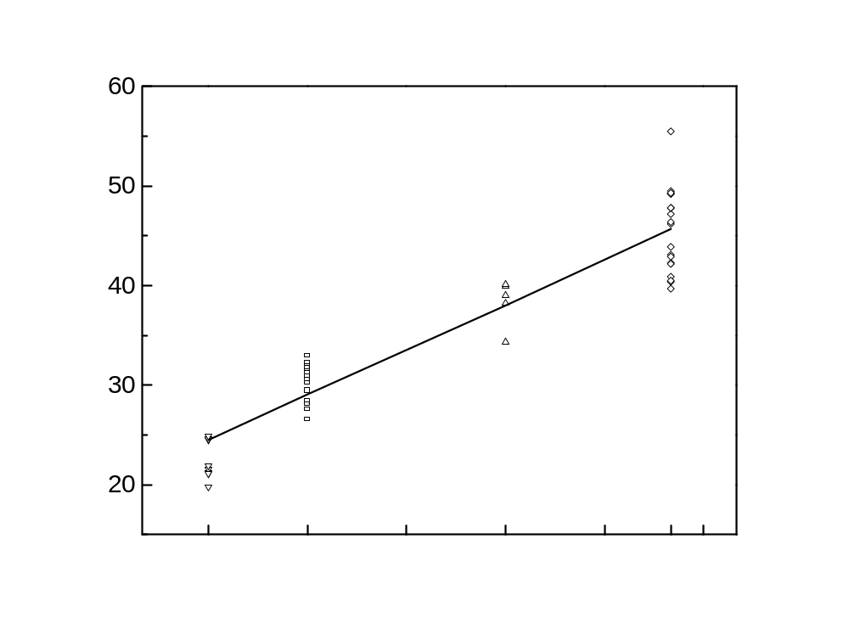
3.0
4.5
7.5
10.0
Sensation levels, S (gm)
Power ratio, PR
Area 1
PR₁ = 3.03(S₁) + 15.43
r = 0.94

Fig. 5.6 Variation of PR with the levels of sensation, S in the medial heel region (area 1) of 50 feet of diabetic subjects from standing foot pressure image analysis.

Table 5.5 Coefficients of correlation (r) between PR values and levels of sensation (S) and the corresponding regression equations in different areas of the foot in diabetic subjects.
Foot areas | Correlation coefficients (r) | Regression equations
1 | 0.94 | PR₁ = 3.03 x S₁ + 15.43
2 | 0.96 | PR₂ = 3.45 x S₂ + 12.94
4 | 0.74 | PR₄ = 2.80 x S₄ + 14.73
5 | 0.79 | PR₅ = 2.93 x S₅ + 14.03
6 | 0.77 | PR₆ = 3.28 x S₆ + 13.21
7 | 0.83 | PR₇ = 3.07 x S₇ + 13.51
8 | 0.78 | PR₈ = 4.02 x S₈ + 08.82
9 | 0.74 | PR₉ = 4.19 x S₉ + 08.02
10 | 0.75 | PR₁₀ = 4.66 x S₁₀ + 4.66

REFERENCES
Annexure -9
- Alexander, I. J. (1990) The assessment of dynamic foot-to-ground contact forces and plantar pressure distribution: A review of the evolution of current techniques and clinical applications, Foot and Ankle, 11, 152–167.
- Armstrong, D.G., Lavery, L.A. and Harkless, L.B. (1998a) Validation of diabetic wound classification system, Diabetes Care, 21, 855–867.
- Armstrong, D.G., Lavery, L.A. and Bushman, T.D. (1998b) Peak foot pressures influence the healing time of diabetic foot ulcers treated with total contact casts, J. Rehabilitation Research and Development, 35, 1–5.
- Barrett, J. P. and Mooney, V. (1973) Neuropathy and diabetic pressure lesions, Orthop. Clin. North Am., 4, 43–47.
- Betts, R. P. and Franks, C.I. (1980) Static and dynamic foot-pressure measurements in clinical orthopaedics, Med. Biol. Eng. Comput., 18, 674–684.
- Boulton, A. J. M. The high-risk foot in diabetes mellitus, pp. 49–59. In R.G. Frykberg (ed.) Diabetic Neuropathy, Churchill Livingstone, New York, 1991.
- Brand, P. Insensitive Feet - A Practical Handbook on Foot Problems in Leprosy, The Leprosy Mission International, Brendford, England, UK., 1989.
- Gonzalez, R.C. and P. Wintz, Image Transforms, Digital image processing, second edition, Addison-Wesley, USA, 1987.
- Habershaw, G. and Donovan, J.C. The diabetic Charcot foot, pp. 32–44. In Kozak G.P., Hoar, C.S. Rowbotham, J.I., Wheelock, F.C., Gibbons, G.W. and Campbell, D. (eds.) Management of Diabetic Foot Problems. W.B. Saunders Co., Philadelphia, 1984.
- Patil, K. M., Prabhu, G.K., Srinivasan, S., Narayanamurthy, V.B. and Parivalavan, R. (2000) Artificial neural network model for analysis of walking foot pressures at different levels of diabetic neuropathy, Proceedings of the 10th International Conference on Biomedical Engineering, pp. 459–460, Dec. 6–9, Singapore.
Note:
- For papers by single authors see example (1)
- For papers by two authors see examples (4,5)
- For papers with more than two authors see examples (2,3)
- For books see examples (6,7,8)
- For articles in edited books / volumes see example (9)
- For papers presented at conference see example (10)
Before binding the project report, the format framed must be shown to their respective guides (May be softcopy) and must take their oral approval so that unnecessary rebinding of project report could be avoided.

The outer covering page must be white in its color with soft bounded/spiral bounded.

NOTE: THE ORIGINAL CERTIFICATE REGARDING COMPLETION OF PROJECT FROM THE COMPANY MUST BE PRODUCED TO THE EXAMINERS DURING VIVA VOCE EXAMINATION.

